publishable summary report

Project Context and Objectives
In EU energy demand, buildings contribute with approximately 40% (in Europe exist around 50.000.000 public buildings). Therefore, the latest EC strategy gives special attention to the existing building stock which, together with the transport sector, has the largest potential to make energy efficiency gains. The efforts aim towards strengthening the EC building performance directive [2002/91/EC] and further increasing building energy efficiency, having a substantial impact on the overall EU energy consumption. In particular, Heating, Ventilation, and Air Conditioning (HVAC) systems represent almost 33% of the energy use in commercial facilities (14% space heating, 10% space cooling and 9% ventilation). Ventilation is also of increasing concern not only from energy saving point of view but also for safety reasons: in many industrial and commercial buildings, hospitals, long-term care facilities and other institutional structures, only 10-15% of the indoor air is fresh, the remaining portion being actually recirculated, mainly because of energy efficiency considerations. These buildings provide environments where large numbers of people spend many hours each day, being potentially exposed to low quality air which can lead to increased presence of allergies or even respiratory diseases.
In this context there is urgent need for novel energy efficient and safe HVAC solutions (with focus on cooling and ventilation issues in commercial buildings) which are able to provide healthier indoor environment.
The NanoHVAC project developed an integrated system, which can be further up scaled in order to provide a commercial solution for the market.
The 3 main components are:
- Insulated ducts with innovative and cost-effective material;
- An injectable liquid polymer matrix (epoxy resins with polyamine derived crosslinking catalyst) for air ducts in situ maintenance activities;
- An anti-microbial, anti-fungal and anti-allergic sprayable and selfadhesive photocatalytic coating, based on titanium oxide nanoparticles, for HVAC filters, activated by a UV LED reactor integrated in the filter.
The demonstration activities carried out in the Demo Park in Madrid showed that the NanoHVAC system reached a good compromise in terms of overall results:
- The insulation material was not so performing as expected: after lab-scale energy performance testing by Sirris of the insulated Aidico prototypes (deliverable 5.2), it was found that the prototypes do not have the same insulation properties as the lab scale small size flat samples tested and produced earlier.
- On that purpose an extra activity was carried out by SIRRIS in order to improve the properties, by exploring the behavior of the material: a series of 114 castings were performed to optimize the foaming behavior with regard to the density. It was observed that the composition of the foam as well as the complexity of the formed part and the casting system have a significant influence on the density distribution in the foam. Since the density will directly determine the heat conductivity, the composition and the geometric complexity are significant factors in the insulation capacity of the tube. The consortium was not able to improve the overall density within the time limitations of the extra task, but has generated valuable knowledge on the foaming mechanisms in 3D castings with the NanoHVAC material system.
- The sprayed filter and the UV LED system are full functioning and their effectiveness on the antimicrobial abatement was demonstrated by the test performed on the field by POLIMI; The integrated system sprayed filter-UV LED system achieved a 93% microbial load reduction.
- No viable microorganisms were detectable after surface sampling on sprayable polymeric matrix-treated ducts, while the untreated ducts displayed 0.45 CFU/25 cm², the antimicrobial effects of the sprayable polymeric matrix-treated duct were thus demonstrated through the testing activities on the Demo Park system.
NanoHVAC system has reached a technology maturity corresponding to a TRL 4 and such level entails that the basic technological components are integrated to establish a comprehensive system which is still at a lab prototype stage, thus it cannot have the reliability of the final system despite the promising results. In fact, during the project a demo of the system was integrated and its functionalities have been preliminary tested in the ACCIONA facility in Madrid.
Timeline
The project lasted 36 months from September 2012 until the end of August 2015.
With respect to the project timeline, specifications and requirements, user needs and component prototyping were developed in the first 28 months of the project; system deployment, installation and configuration, testing in the Demo Park in Madrid, were basically carried out during the last 8 months of the project. Also exploitation activities were mainly carried out towards the end of the project.
Work Plan
The work has been divided in 7 main technical Work Packages where the R&D activities were developed, and one additional Work Package of management (WP9) and one for dissemination and exploitation activities (WP8):
- WP1 Requirements, standards, building codes and Conceptual Design: led by VENTO, was focused on
  - Performing a comprehensive market analysis and analyse market trends and application potentials for the new NANO-HVAC materials and solutions;
  - Setting of rational criteria for selection and development of the new materials and the related production processes as well as the nano-enabled comprehensive solutions for HVAC ducts and filters.
- WP2 Sprayable aeroclay based foams for improving thermal insulation of HVAC ducts: the objective of WP2, led by AIDICO, was to develop a sprayable aeroclay based material for application onto HVAC round duct elements (but also on squared ones) that fits the following main functions and specifications:
  - Product functions: Thermal insulating coating for temperature range: 20- 400 º C; Thermal insulating coating with fire resistance properties at temperatures >800 ºC.
  - Technical specifications:
    - Heat conductivity of less than 0,02 W/mK;
    - Curing times: 2 to 3 hours a ambient temperature;
    - Density lower than 30 Kg/m3;
    - Thixotropic properties;
    - Complying to the strictest EU standards for combustibility resistance and fire safety (A1/A2Class);
    - Water and salt resistance;
    - Either sprayable or injectable casting methods can be used according to the results obtained in WP1 and foreseen application.
- WP3 Pathogens and allergenics inhibition and removal: led by NANOPHOS, has the objective to develop a set of anti-microbial, anti-fungal and anti-allergic solutions for HVAC ducts and filters, and in particular:
  - A sprayable, water based and self-adhesive nano-enabled photocatalytic coating for filters;
  - A suitable energy efficient UV lighting system for optimal photocatalytic performance
  - Development of low cost and efficient duct cleaning procedures with development injectable nano-enabled polymeric coating
  - Preliminary characterization of such developed coatings and their components
- WP4 Component Prototyping and Integration: led by VENTO, had the objective of developing the working prototypes developed within WP3, considering also cost-effectiveness issues as well as health and safety aspects. The main targets were:
  - Development of working prototypes of energy efficient and safe resistance insulating HVAC ducts;
  - Development of working prototypes of filters with anti-microbial anti-allergic coatings and related LED lighting system to activate them;
  - Development of working prototypes of a system to inject the nano-enabled self adhesive polymer for easy HVAC duct cleaning and disinfection during periodic HVAC maintenance.
  - Integration of all these solutions into a HVAC system, ready for testing in WP5.

- WP5 Lab-Scale Testing: the objective of this work package, led by POLIMI, were:
  - Test in vitro the effectiveness of filter coatings;
  - Test the NANO-HVAC lab-scale system against a comparable conventional system, in order to check that the overall energy saving is around 50% as compared with conventional system;
  - Evaluate the microbial abatement into a small-scale testing chamber mimicking a typical commercial environment with microbiological pollutants. No human toxicity texts was performed and expected.
- WP6 Full scale Demo and Validation: it was led by ACCIONA, the objectives were:
  - The development of a full scale demonstrator to validate the NANO-HVAC system in a demo commercial building;
  - The validation of energy consumption of the NANO-HVAC system as well as the temperature distribution;
  - The validation of the antibacterial, antifungal and VOCs, NO, and CO abatement potential of the NanoHVAC system.
The validation of the NANO-HVAC will be performed mimicking the actual installation conditions in a building site as well as the operation and maintenance conditions of a commercial building.
- WP7 HSE Assessment, LCA and LCCA: led by D’APPOLONIA, the objectives were:
  - To review of the hazard and exposure potential of nanomaterials related to the projects, based on current published literature;
  - The Development of basic risk assessment and guidance on risk management and best available techniques to minimise and control any health risks to manufacturers, researchers and end-users;
  - To perform a life cycle cost assessment for the different NANO-HVAC components and for the whole system throughout its whole life cycle (from-cradle-to-grave);
  - To make an analysis and assessment of the potential environmental impacts of NANO-HVAC products and services with life cycle approach..
- WP8 Exploitation, dissemination and IPR management: led by NTUA, the objectives were the valorisation of the project results in terms of their dissemination and exploitation. Dissemination activities took field with the public webpage, project presentations, stakeholder visits, workshops and other dissemination events and materials (e.g. video presentation), publications to scientific papers, and press conference. Project deliverables are publically available on the private area of the project website (www.nanohvac.eu). Exploitation activities allowed the consortium to identify 5 main exploitable project results and related exploitation strategies. The identified results are:
  - Novel aeroclays-enabled insulating materials for HVAC applications, applied by casting, injection or spraying, during duct manufacturing (AIDICO)
  - New filtering and disinfection system for new and existing HVAC ducts with sprayable, water based and self-adhesive nano-enabled photocatalytic filter coating and integrated UVA LED lighting source for activation of the photocatalytic process (NTUA)
  - Innovative injectable nano-enabled polymeric coating for duct cleaning (FARBE)
  - New duct system, integrating all NANO-HVAC innovative products and solutions, enabling high insulation as well as easy and effective cleaning and maintenance (VENTO)
  - Water based photocatalytic formulations for HVAC filters treatment (NANOPHOS)

S&T Results
The project has acceptably achieved the intended result of developing, demonstrating and validating an innovative HVAC system with enhanced antimicrobial and antibacterial countermeasures, with a positive impact on the maintenance cost all along the lifetime of the system.
Achievements | Shortcomings
Novel aeroclays-enabled insulating materials for HVAC applications, applied by casting, injection or spraying, during duct manufacturing | The performance of the demo-material was not as expected (after lab-scale results): on that purpose an extra effort was made by SIRRIS in order to achieve a better insulation performance.
New filtering and disinfection system for new and existing HVAC ducts with sprayable, water based and self-adhesive nano-enabled photocatalytic filter coating and integrated UVA LED lighting source for activation of the photocatalytic process | -
Innovative injectable nano-enabled polymeric coating for duct cleaning | The spraying method must be improved and be adaptable for different type of HVAC duct system and building typologies
New duct system, integrating all NANO-HVAC innovative products and solutions, enabling high insulation as well as easy and effective cleaning and maintenance | The energy consumption of the system was not adequate: the energy saving target was not achieved, mainly due to the under performing insulation material
Water based photocatalytic formulations for HVAC filters treatment. | -

This overall achievement is the result of what obtained within each Work Package and the key deliverables as described in the following paragraphs.
WP1 Requirements, standards, building codes and Conceptual Design
D1.1 Market analysis
Intent: the aim was market trends and application potentials for the new NANO-HVAC materials and solutions
Highlights: A market analysis was carried out, in order to highlight relationships between the market, and the social and strategic factors which are related to the introduction of environmentally and energy friendly NANO-HVAC devices. Also an analysis of existing insulating duct solutions as anti-microbial coatings for ducts and filters and cleaning and maintenance procedures was carried out through scientific literature analyses and patent analyses, identifying several interesting solutions for the development of NANO-HVAC products. It also included an overview of most common insulation materials used for several applications which represents the current state of the art.
The analysis confirmed that NANOHVAC innovative approach for ducts insulation could be a breakthrough technology among currently commercialized products, with the capability to go in recognized markets and gain prominent market share.
D1.2 Rational criteria for selection of materials and development of products and solutions
Intent: to set the maximum target for the selection of raw materials and the development of the NanoHVAC components
Highlights: The overall technical specifications and requirements were defined, setting ambitious targets and analysing the EC legislation, existing building codes and standards relevant for HVAC ducts.
WP2 Sprayable aeroclay based foams for improving thermal insulation of HVAC ducts
D2.1 Report on aeroclay powder preparation
Intent: to prepare the aeroclay powder material
Highlights: Firstly the freeze drying process was defined, then the powder preparation: in the end the aeroclay was characterized. This task resulted in novel aeroclay materials which can be integrated in the envisaged foamed composite structure using the binder system developed in task 2.
D2.2 Report on developed inorganic binders
Intent: To produce and develop the inorganic binder for the next stage of the material
Highlights: AIDICO performed a formulation study on different silicate systems, binder types and ratios to determine an appropriate binder system for the insulation material. the influence on mechanical and rheological properties and setting time were investigated. This task resulted in the selection of as specific sodium silicate system with propylene carbonate as hardener, which will be used for task 3.
D2.3 Report on lab-scale procedure for the synthesis the best performing foams
Intent: To select and optimise the production process for preparing the chemical foam
Highlights: All the formulation design and laboratory trials following the protocols for processing with variable amounts of materials were described in this deliverable, in order to obtain the lower values of final densities (after total dryness) with acceptable mechanical stability. The foam formulation work was based on a combination of previously designed silicate binder and aeroclay, and additional fiber and additives to provide reinforcing and blowing effects
D2.4 Optimal spray conditions established to reach high porosity
Intent: to develop a spray/blow deposition method; this can be compatible with the properties material, in order to guarantee the characteristics and properties
Highlights: The developed process combines blowing technologies based on gas generating additives (activated hydrogen peroxide) with foaming technologies based on reducing the water surface tension.
D2.5 Summary of insulating material testing
Intent: To preliminary test the characteristics of the insulation material at lab-scale
Highlights: Based on D1.2, where rational criteria for selection of products and solutions regarding the new NANO-HVAC materials were defined, in D2.5 a matrix of tests was suggested to analyse the newly developed product. The different properties are analysed using standard test methods, as indicated in the table below.
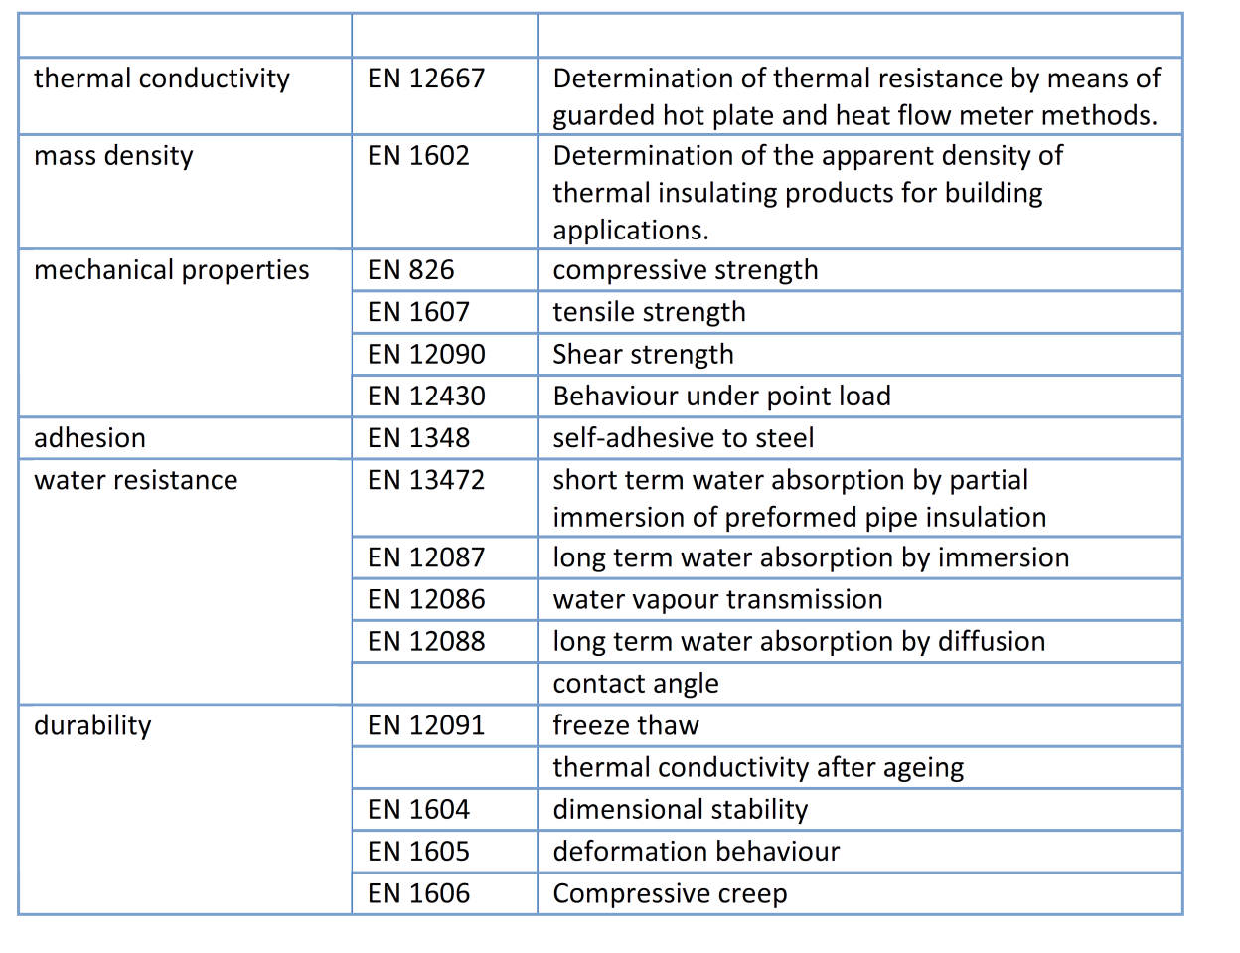
WP3 Pathogens inhibition and removal
D3.1 Report on developed titanium oxide and silver nanoparticles (TiO₂ and Ag NPs)
Intent: to define the characteristics of the development process of TiO₂ and Ag NPs which were used in the filter coating and in the liquid polymer matrix, respectively.
Highlights: The process to obtain the NPs was extensively described, by providing details on the experiments and production process.
D3.2 Report on developed anti-microbial filter coatings
Intent: to develop a method to prepare a coated filter with NPs, which can be used on HVAC application, and test the photocatalytic properties of the coating
Highlights: Photocatalytic formulations were successfully developed using TiO₂ NPs, produced by ICAA and NanoPhos. The particles were stabilized by additives and ultrasounds, while they became self-adhesive coupled with an inorganic binder. The stability of the formulation, measured by zeta potential, showed that it can stand harsh conditions and easily applied on substrates by simple spraying.
D3.3 Report on the designed lighting system for optimum photocatalytic performance
Intent: To make an overview of the UV-based disinfection system, in order to propose a lighting system design and to identify the necessary materials for the manufacturing of the lighting system. Additionally, to develop a calculation model for the estimation of the irradiance intensity based on geometrical characteristics of the placement between the lighting source and the filter
Highlights: Initially, an overview of UV-based disinfection systems and their main components are presented followed by a discussion concerning the main parameters that influence system performance. Subsequently, a UV irradiance modelling procedure is adopted and a calculation model is developed that is able to calculate the UV irradiance in a filter based on the specifications of the UV light source and the geometrical characteristics between the lighting source and the filter placement. Based on all the above, the proposed design of the lighting system was presented. Finally, an extended patent analysis on photocatalytic coatings for anti-microbial integrated systems was carried out in order to avoid any existing patent infringements issues.
D3.4 Report on nano-enabled polymeric coating for advanced and automatic HVAC cleaning
Intent: To develop a low cost and efficient duct cleaning procedures with development injectable nano-enabled polymeric coating
Highlights: a liquid polymer matrix with the addition of silver nanoparticles provided by ICAA was developed: in Task 4.3 ” Prototyping of sprayable nano-enabled polymeric coating for effective HVAC cleaning” the liquid polymer matrix was further developed and fine-tuned in order to cover the gap between the laboratory preparation of the product and the demonstration phase. At that stage the formulation with the silver nanoparticles showed good rheological performance.
D3.5 Preliminary characterization of NPs and related coatings
Intent: to make a preliminary characterization of the NPs used in the coated filter and in the liquid polymer matrix
Highlights: Titania and Ag NPs and their coatings on different kinds of filters have been characterized. Nanoparticles fulfil or even excel the established criteria for selection of materials and development of products and solutions in terms of hydrodynamic and dry crystallite size, surface (zeta) potential and specific (BET) surface areas. Commercial filters with expected low pressure drop can be efficiently coated with suspensions formulated with the titania and Ag NPs characterized in this report. The used spraying procedure for coating can be easily scaled up. Ag NPs selected after physical-chemical characterization show significant antibacterial activity against Staphylococcus aureus and Escherichia coli, with population reduction ≥ 99.72 % for the best samples. Under UV irradiation, selected titania NPs also show high antibacterial activity against S. aureus and K. pneumoniae with population reduction >99.55% for the most effective samples. The high antibacterial activity of titania-coated surfaces was also preliminary demonstrated for E. coli and S. aureus. The antifungal activity of TiO₂ NPs under UV radiation was also demonstrated for A. aculeatus and P. chrysogenum.
WP4 Component Prototyping and Integration
D4.1 Availability of prototypes of insulating ducts
Intent: to upscale the production process and deliver prototypes of the insulated ducts
Highlights: Insulated ducts were produced, trying to identify several configurations (e.g.vertical or horizontal) for the manufacturing process: .Prototype ducts of 2 meters length and 10 cm diameter together with PVC moulds of 2 m length and 15 cm diameter were prepared in order to define the injection process parameters. The results in terms of performance and characteristics are not in line with the lab-scale material, and this result affected the next phase of the project.
D4.2 Availability of prototypes of filters with photocatalytic coating
Intent: to develop a method of spraying and a photocatalytic coated filter to be inserted in the NanoHVAC system, integrated in the filter box and also to integrate the lighting source to the filter-box configuration
Highlights: The manufacturing process related to anti-microbial and antiallergenic photocatalytic coatings applied on filter for HVAC systems was built, special designed with a LED system for activation. The simulation of photocatalytic degradation was carried out by the removal of acetaldehyde, which was selected as a target compound for indoor air pollution. Also the design with a CFD model was made, in order to optimise the system and the filter box.
D4.3 Availability of prototype of sprayable nano-enabled polymeric coating and HVAC cleaning system
Intent: to develop an optimized formulation of the liquid polymer matrix and a method to spray it
Highlights: FARBE developed working prototypes of the system which enable easy injection of the developed materials. The resulting prototypes and the injection system were built: two main optimized compositions have been identified, one with nanoparticles and one without nanoparticles. The test showed a better rheological performance of the optimized formulation of the liquid polymer matrix without nanoparticles.
D4.4 Availability of lab-scale nano-HVAC prototype
Intent: to integrate and design all the developed components for the testing foreseen in WP5
Highlights: The system was built into three separate systems, in order to facilitate the testing activities, namely the energy efficiency measurement, removing airborne bacteria measurement and the evaluation injection matrix polymeric coating. The necessary insulated duct parts for the energy efficiency measurement setup were produced: 4 bends and 5 3m straight tubes of diameter 125 with 25mm insulation thickness.
WP5 Lab-Scale Testing
D5.1 Determination of the antimicrobial activity of photocatalytic surfaces and nanoparticles.
Intent: to test the effectiveness in terms of microbial abatement of the coated filters and the sprayed surface with liquid polymer matrix (task 5.1).
Highlights: As extra-activity not scheduled, a preliminary antimicrobial characterization of both ICAA and NANOPHOS TiO₂ NPs coated onto flat glass surfaces was assessed, in order to select the most effective coating after NPs deposition on a support. The most effective coating (NANOPHOS NPs) was applied to filters and challenged in vitro for antibacterial and antifungal activity. As extra-activity, we assessed the antimicrobial activity on 5 prototype filters (instead of 1) differing for thickness. The minimum antimicrobial performances reported in the DoW (Antimicrobial efficiency validation criteria for filter coating) were fulfilled, with an average 70-80% reduction of microbial population. Instead, nano-enabled polymeric coatings (with 0.5% or 1% of Ag NPs) were only slightly more effective than plain polymeric matrix in killing microorganisms. Nevertheless, because the main function of the polymeric matrix is the mechanical trapping and embedding of microorganisms onto the inner surface of pipes, the Consortium decided to use the plain polymeric matrix instead of the Ag-doped one.
D5.2 Determination of energy performance of the nano-HVAC lab-scale system
Intent: To evaluate the insulation performance of the ducts in terms of temperature distribution and energy saving.
Highlights: The experiments done indicate that the tested material is different from the material prepared at labscale, because it shows a higher 𝜆-value, and thus a worse insulation quality. The tested nanoHVAC material displays a higher 𝜆-value than that of mineral wool used as reference. The nanoHVAC system also shows a higher heat capacity. Due to this, the amount of energy needed to heat up and maintain the system at higher temperature, is higher than in the case of mineral wool. With the material tested, an energy increase instead of an energy saving is obtained and the objective of a 50% energy saving is not obtained with the tested nanoHVAC material.
In the set-ups used, 35% more energy is needed to heat up the delivered nanoHVAC insulated system compared to the mineral wool system. Once in the steady state, in the set-ups used and the time interval measured, 25% more energy is needed to keep the nanoHVAC system at the set temperature, compared to the mineral wool system.
Thermal imaging showed a more uniform insulation capability for the NanoHVAC system. In case of the mineral wool system it was seen that the bends show increased losses compared to the straight ducts. This demonstrates that mineral wool insulation of complex parts is difficult and a casting system like the NanoHVAC technology can create a significant benefit when the lambda value can be optimized.
D5.3 Antimicrobial efficiency of air filters in a small-scale testing room
Intent: To make an evaluation of the antimicrobial potential of air filters in a controlled environment conceived ad-hoc and equipped with photocatalytic air filters and mounted in HVAC systems.
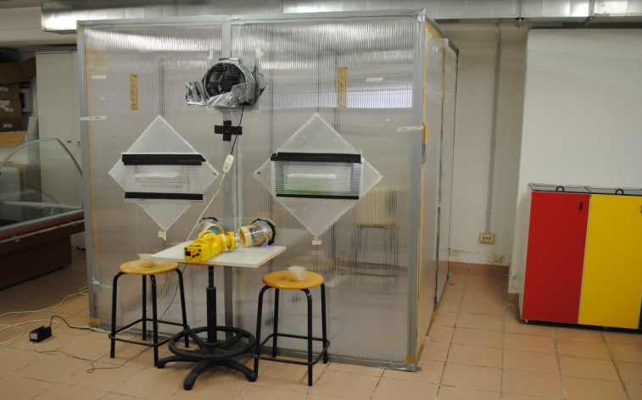
Highlights: A Lab scale system of 2 identical testing chamber (Figure A, B below) were used to carry out all the experiments. Each chamber is 4 m³. A downscaled HVAC system provided by VENTO was designed ad-hoc and assembled to fit the size of the testing chamber. Experiments were always ran in parallel in each identical testing chamber, one installed with the device with the coated filter with or without LED UV lightening, while the other with the untreated filter (with or without LED UV lighting).
NANO-HVAC
25 cm
Reference HVAC
A
B

The results reported and presented in D5.3 (and in figure below), confirmed the effectiveness of NANO-HVAC technology to reduce the microbial population in a lab-scale testing chamber. At very short time points NANO-HVAC technology (treated filter 5 + UV irradiation) was MUCH MORE EFFECTIVE in removing airborne microbial contaminants than Reference system Noteworthy, among the 5 filters tested the filter called “number 5”, with NANO-HVAC technology, was the most effective in removing airborne microbial contaminants.
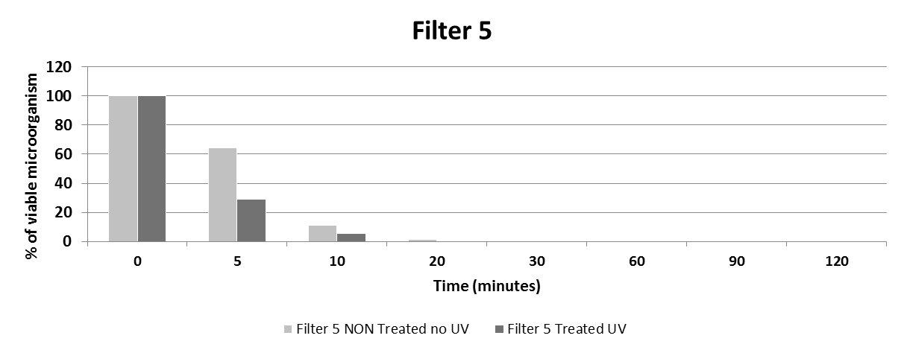

WP6 Full scale Demo and Validation
D6.1 Full scale NANO-HVAC demonstrator in a demo building
Intent: To build a full scale demo of the nanoHVAC system in ACCIONA’s facility
Highlights: According to the DoW, the developed system was to be installed by ACCIONA in a demo commercial building. Due to technical reasons and in order to gather more complete set of results, during the Technical Project Meeting that took place in Rome on the 20th of November 2012 the NanoHVAC Partners agreed on the ACCIONA’s proposal to transfer scheduled studies to the ACCIONA´s Demo Park instead of a commercial building.
This solution allowed making possible to carry out a comparative validation test of two systems: the new one NanoHVAC and Reference traditional system in the same indoor and outdoor conditions.
The system was installed in the Demo Park in Madrid: Since NanoHVAC project aims to validate NanoHVAC thermal performance through a full-scale comparative test, the two demonstrators were thermally analyzed before materials installation campaign, in order to confirm the same boundary conditions which are shared for both rooms.
D6.2 Energy performance validation of NANO-HVAC demonstrator
Intent: To make a comparative analysis of energy consumption for keeping comfort indoor conditions in the two demo buildings by the two HVAC systems: NanoHVAC and REFERENCE carried out in parallel.
Highlights: Thermal results were achieved during a testing period of 46 days between June 1st 2015 and July 16th 2015, which has been demonstrated to be enough to collect a full set of significant data. Thermal conditions can be considered extreme since the ducts has been exposed to very high temperatures for several days (60°C at midday in the final period of the demonstration).
Mock ups’ boundary conditions were comparable ( in terms of internal temperature, averaged temperature values for interior machine output flow and air duct input flow): the final result of the energy consumption analysis is represented in the figure below.
NanoHVAC final energy consumption is equal to 507.1 kWh, while REFERENCE has been 499.8 kWh, which is a 1.44% lower. On the other hand, two different slopes can be observed in the curve, that are directly related with weather conditions: while during the first days of the experiment maximum temperatures rose up to 45°C, in a second phase maximum peaks during midday beat 60°C, which supposes a high operation ratio for the HVAC machine. The
Traditionally mineral wool presents lambda values within 35-40 mW/mK, while thermal characterization under Standards on NanoHVAC lab scale samples have shown values between 35-37 mW/mK.
D6.3 On-site validation of the antibacterial antifungal and VOCs, NO, and CO abatment potential of demonstrator
Intent: To test and validate of the antimicrobial activity potential of HVAC system and VOCs, NO, and CO abatment ability of the system.
Highlights: The detection and monitoring of airborne microbial contaminants were carried out by “active sampling”, collecting airborne microorganisms with the appropriate sampling device. Defined volumes of air were aspirated at different time points The antimicrobial efficiency and microorganisms removal was assessed by testing different conditions as treated and non-treated prototype filters into NANO-HVAC system, NANO-HVAC system without any filter, Reference HVAC system in Reference mock-up.

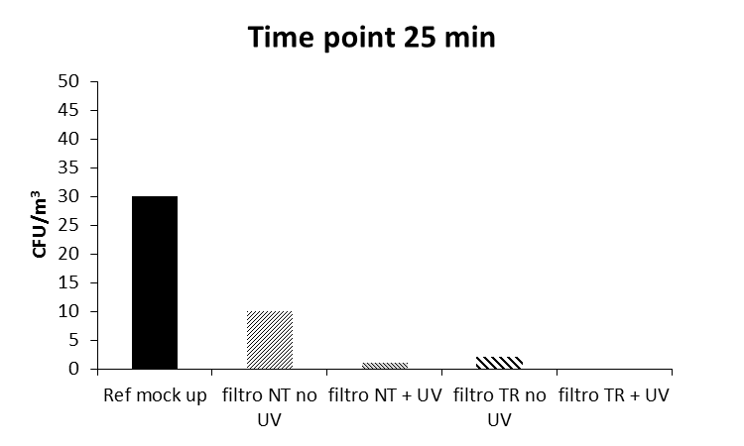
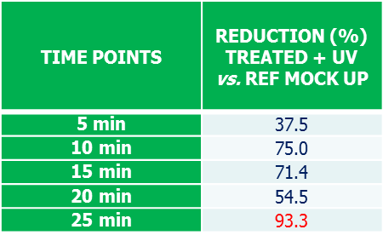
The antimicrobial efficiency, detected by collecting airborne microorganisms with the appropriate air sampling device, was evaluated over a 25 min-interval of time. At each time point analysed, some differences were evaluated between the Reference HVAC system (Reference mock-up) and the system installed with NANO-HVAC technology. In particular, for the conditions with treated filter with or without UV irradiation, the airborne microbial population was almost completely reduced with respect to the Reference mock-up or the system with non-treated filter without UV irradiation (Figure below).
93 % reduction
Measurement of VOCs, CO and NO outdoor, in Reference (commercial HVAC system) and NANO-HVAC mock-up were performed as extra activity. The results obtained related to indoor air quality (IAQ) analysis of the NANO-HVAC technology vs. Reference system, together with result related to the determination of antimicrobial efficiency, confirmed the effectiveness of NANO-HVAC technology in reducing the microbial population and minimizing VOCs and other gaseous contaminants.
D6.4 Improvement of the upscaling process development
Intent: To analyse the performances of the insulated ducts and to investigate the feasibility of alternatives
Highlights: A series of 114 castings were performed to optimize the foaming behavior with regard to the density. It was observed that the composition of the foam as well as the com-plexity of the formed part has a significant influence on the density distribution in the foam. Since the density will directly determine the heat conductivity, the composition and the geometric complexity are significant factors in the insulation capacity of the tube.
WP7 HSE Assessment, LCA and LCCA
D7.1 Exposure scenarios
Intent: To Review the hazard and exposure potential of nanomaterials related to the projects, based on current published literature
Highlights: Hazard Exposure Characterization has been performed on the entire lifecycle of the NANO-HVAC Products, during the lifecycle of the equipment, including manufacturing, transport to site, installation, commissioning/start-up, multi-years operation, maintenance, dismantling (at the end of the useful life) and disposal. The identification of the exposure pathways has been here developed following a conservative approach, and each possible exposure pathway has been considered a credible potential primary route of contact with nano-materials unless a physical segregation exists.

D7.3 Risk assessment
Intent: To prepare a risk assessment, estimating the potential risk to human health from the used or developed nanoparticles
Highlights: Risk assessment was performed for all those scenarios which arise from the innovative features of NANO-HVAC systems. Hazards and related consequences typical of standard HVAC systems are not further assessed, since not Project-Specific. In the D7.3 are included the development and results of the NANO-HVAC Products Risk Assessment, including the applied methodology, the performed analysis on the 22 identified different possible scenarios and the overall findings of the analysis, which demonstrated that all the potential hazards posed by the Project are always controlled and tolerable according to widely accepted criteria.
D7.4 Life Cycle Cost Assessment - update
Intent: to make a techno-economical assessment will be carried out for each of the NANO-HVAC products and services and for the whole system that will be implemented within the project.
Highlights: During the LCCA two different systems have been considered:
• Standard HVAC system, used as reference;
• Innovative HVAC system where innovative components developed and manufactured during the project have been inserted in detail:
- Silver and Titanium Dioxide nanoparticles;
- Anti-microbial Coating;
- Photocatalytic coating for filter with Titanium dioxide nanoparticles;
- UV lighting system;
- Aero clay/inorganic binder/final foam material.
In order to warrant a solid comparison, the two systems have been installed in two rooms (i.e.: containers), located in Algete Demo Park, in Madrid, owned by Acciona, one of project partners. Respectively the two rooms (cooled for 25 years with a system installed at time zero) have been defined as functional unit and the costs (i.e. personnel, energy, raw materials) are associated to Spain (site of use). All the data have been properly referenced. In particular the analysis has highlighted that: the innovative Nano-HVAC system is more convenient in terms of initial investment cost as well as operational costs during the life time frame.
D7.5 Life Cycle Assessment - update
Intent: To take into account all the processes, starting from the raw materials production, through materials processing, nanoparticle and coating manufacture, distribution, use, cleaning and maintenance procedures and disposal, and to analyse the impact of the NANO-HVAC solutions at the different scales, local, national and European.
Highlights: The Life Cycle Impact Assessment (LCIA) evaluates the amount and significance of the potential environmental impacts arising from the LCI. Inputs and outputs are assigned to impact categories and their potential impacts quantified according to characterization factors. The NanoHVAC system has similar environmental performances for the majority of assessed indicators compared to a standard system, with some specific benefits related to Eco and Human Toxicity and Freshwater Eutrophication. Probably a further R&D work needs to be performed on several specific components, in order to maintain good results in manufacturing phase, but implementing the benefit in terms of energy consumptions during use phase.
WP8 Exploitation, dissemination and IPR management
D8.5 Plan for Use and Dissemination of Foreground - final
Intent: to disseminate the project public results in order to engage with the public

Highlights: The PUDF includes the publications and all the dissemination events in which the NanoHVAC was presented. The plan is divided into two sections: one related to results that have been disseminated and dissemination activities, including scientific publications, and one that describes exploitable results and related activities, which remain confidential, at least until the protection and the economic exploitation of the results have been implemented.
D8.6 Report on Dissemination activities and Exploitation activities
Intent: to collect all the dissemination activities, including also the report of training workshops and the developed training manual and the results of the final dissemination conference.
Highlights: in the D8.6 there is the description of all the dissemination activities undertaken by the Consortium, so as the training manual developed by Acciona. First, the project’s as well as the partners’ logos are presented. An analytical description of the official website and the pamphlet of the project is included. Additionally, a brief description from all the events and conferences in which the project has been presented, is given.

Potential Impact
Current forecasts predict irreversible global climate change unless the emission of greenhouse gases can be
reduced rapidly by 40% with respect to 1990 levels, within a decade (Schellnhuber et al. 2010). Already new
targets are under discussion for reduction of greenhouse gas emissions to 90% below 1990 levels by 2050
(Atomium Culture 2010). It is generally accepted that this level of adjustment demands a paradigm shift in
behavioural change rather than incremental change, which has to be supported by new technologies and
social governance.

At the same time, buildings are responsible for about 40% of energy consumption and about 36% of all greenhouse gas emissions in Europe. Heating, cooling and ventilation in commercial buildings are responsible for 35% of CO2 emissions and of almost 33% of energy consumption.
The project addresses the major challenge in ventilation system related to poor air quality, through its set of anti-microbial and anti-allergic solutions and strategies for increased indoor comfort.

Commercially available technologies and products were characterized, in order to identify the market and technological potential of the NanoHVAC solution, by investigating the main components
- Insulation materials
- High insulating materials
- Innovative materials
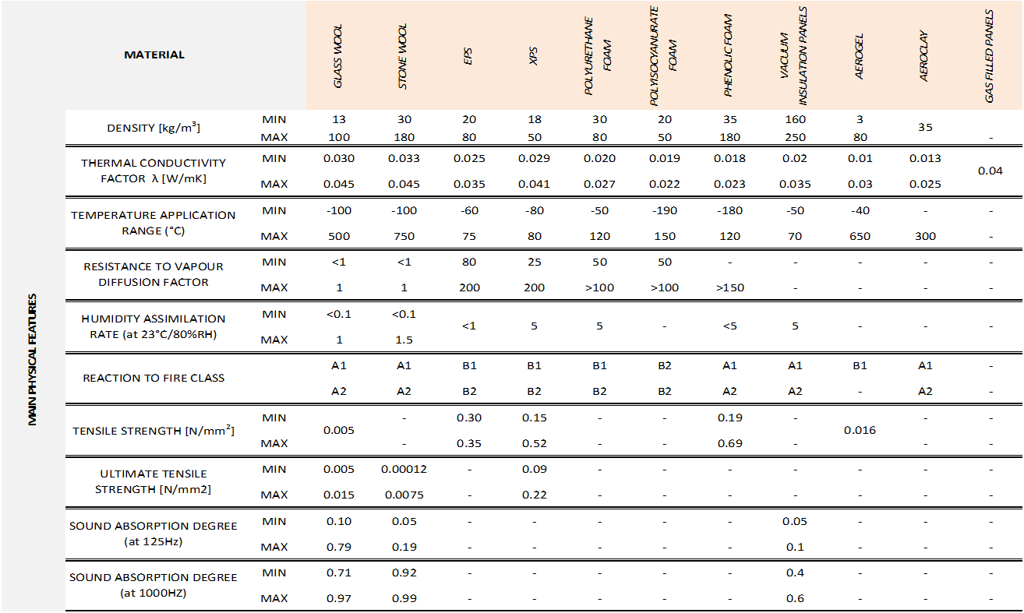

The solution provided by NanoHVAC project can result particularly useful in harsh environment and specific HVAC system in buildings: NANO-HVAC system can drastically improve air quality in buildings, impacting on people health and wellbeing. In fact, many workers spend long periods of time indoors, in air-conditioned buildings. If the air conditioning system is not maintained, a number of problems, some potentially lethal, can occur.

The main outcome of the project were:
- New aeroclays-enabled insulating duct coating, automatically applied during duct manufacturing;
- development of innovative injectable nano-enabled polymeric coating for duct cleaning
- development of sprayable, water based and self-adhesive nano-enabled photocatalytic coating for filters integrated with a proper UVA lighting system for activation of photocatalysis;
- development of a new duct system, integrating the products and solutions above, enabling high insulation as well as easy and effective cleaning and maintenance.

At the end of the project several results are available:
- New filtering and disinfection system for new and existing HVAC ducts with sprayable, water based and self-adhesive nano-enabled photocatalytic filter coating and integrated UVA LED lighting source for activation of the photocatalytic process (NTUA)
- Innovative injectable nano-enabled polymeric coating for duct cleaning (FARBE)
- New duct system, integrating all NANO-HVAC innovative products and solutions, enabling high insulation as well as easy and effective cleaning and maintenance (VENTO)
- Water based photocatalytic formulations for HVAC filters treatment (NANOPHOS)

- The target of 50% of energy saving for the NanoHVAC System was not achieved, due to some problems in the insulation material development: on that purpose the amendment procedure was requested to address this issue and trying to overcome the problem.

Demonstrator tubes were manufactured by Aidico. It was observed that the properties of the demonstrators in terms of densities were not in line with the densities reported earlier at lab scale ->
First energy performance tests of demonstrator tubes showed that the proto-types did not have the same insulation properties as the characterization of the earlier reported lab scale castings.
An extra effort was made by the Consortium, deciding to go for an improvement of the formulation at lab-scale and trying to identify parameters that influenced the unexpected performance. Several conclusions and recommendations were made after this extra activity on the
- Mold technology
- Aerogel
- Advised formulation
which can be useful for a further development of the insulation material.
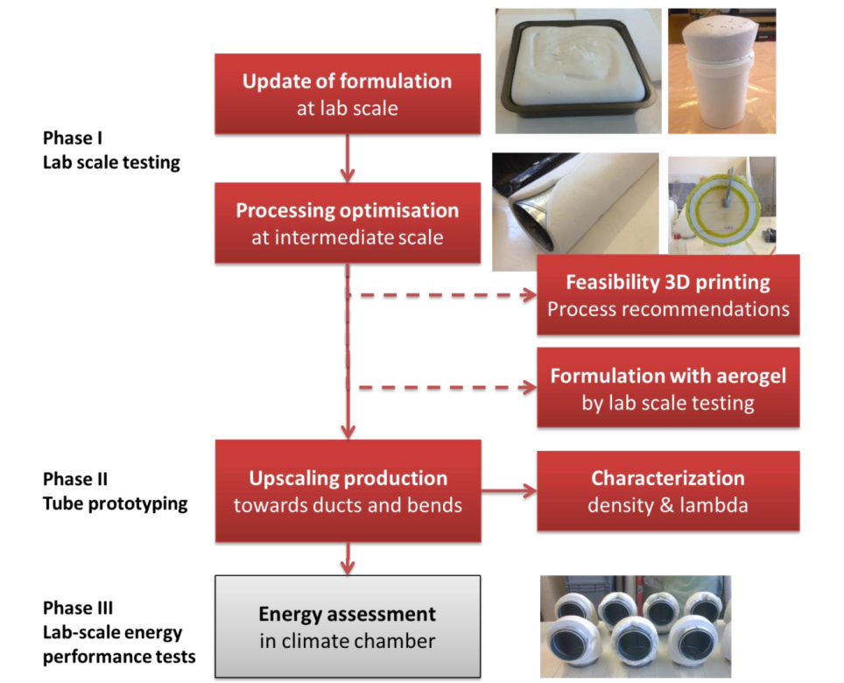

- The liquid polymer matrix applied in the Demo Park in Madrid showed an efficient result in terms of antibacterial and antifungal abatement.
- The Air disinfection system for ducts is an integrated solution for HVAC duct networks: thanks to the UV LED lighting system and the coated filter the duct network can be easily disinfected, cleaned and maintained by using nanotechnology. It is also a cost-effective and low-energy consumption solution, using both commercial and new technology products and consists a product that could be available in the market in the near future.
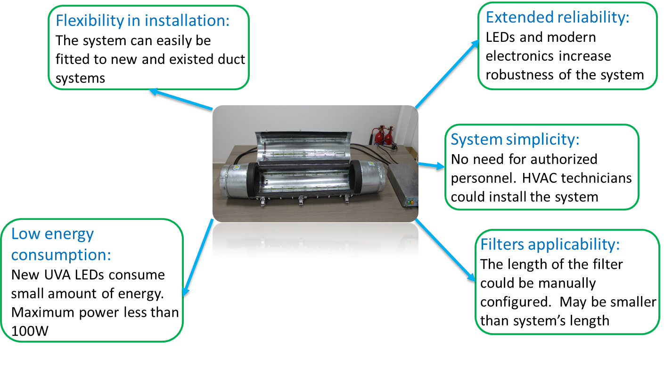

The system showed also an excellent antimicrobial reduction performance: the test performed in Madrid by POLIMI identified that the joint impact of the coated filter and the UV LED system leaded to a reduction of the microbial load of 93,3%.
It was demonstrated that the NANO-HVAC technology is
- Extremely effective in removing airborne microorganisms;
- Extremely effective in reducing surface contamination;
- Extremely effective in the abatement of V.O.C.s , CO and NO load

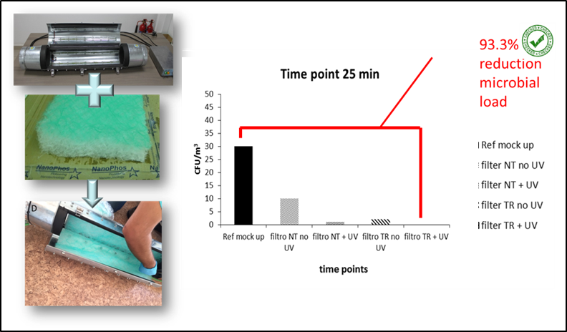

- Moreover the The LCA-LCC analysis carried out in WP7 showed that the NanoHVAC system has
- Longers filters lifetime
- Less environmental burdens (using aeroclay foam instead of mineral wool)
- the Photocatalytic Coating as well as the introduction of UV lighting system, generate, together with the new ducts, impacts globally less than the impacts of standard ducts.

From the cost point of view, the NANOHVAC system is less expensive and could be a candidate for the substitution of the State of Art HVAC or part of it. Considering the cooling of a room of 17,67 m2 for 25 year was estimated a total saving generated by the innovative solution equal to 2.772 € (i.e. 157 €/m2) in 25 years that is a 19% less respect to the standard system

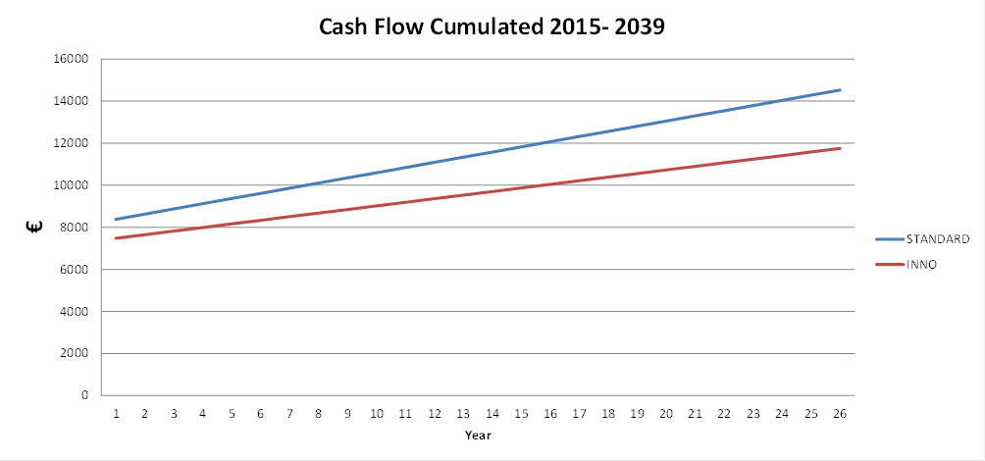

Each result was characterized by describing the main features: a detailed description was made, by determining also the results characterization defining the potential market exploitation and the related intention of the partners to exploit the results.

Contact Details

Please visit our webpage at www.nanohvac.eu

VENTO BV, Bart Modde (Project coordinator)
E-mail: bart@vento.be
Website: www.vento.be
Phone: Tel: +32 (0)55 30.47.20
Fax: +32 (0)55 30.47.21
Address: Bedrijvenpark Coupure 5,9700, Oudenaarde, Belgium

D’Appolonia S.p.A., Federico Di Gennaro
E-mail: federico.digennaro@dappolonia.it
Website: http://www.dappolonia.it/en
Phone: +39 010 3628148
Fax: +39 010 3621078
Address: Via San Nazaro 19, 16145 Genova, Italy

NANOPHOS A.E. , Ioannis Arabatzis
E-mail: iarabatz@nanophos.com
Website: www.nanophos.com
Phone: (+30) 22920 69312
Fax: (+30) 22920 69303
Address: Technological & Science Park, Lavrio, Greece 19500

ICAA. , Radita Gardu
E-mail: radita.gardu@icaaro.com
Website: www.icaaro.com
Phone: +40 21 345 2730.
Fax: +40 21 345 0595
Address: Bulevardul Theodor Pallady 49a , 0322258 Bucharest, Romania

Politecnico di Milano , Gabriele Candiani
E-mail: gabriele.candiani@polimi.it
Website: www.polimi.it
Phone: +39-02-23993090
Fax: +39-02-23993180
Address: Politecnico di Milano, Edificio 8, via Mancinelli 7, 20131 Milano (Italy)

SIRRIS , Heidi Van den Rul
E-mail: heidi.vandenrul@sirris.be
Website: www.sirris.be
Phone: +32 498 91 93 14
Fax: -
Address: Wetenschapspark 3 B-3590 Diepenbeek, Belgium

INL , Carlos Rodriguez
E-mail: carlos.rodriguez@inl.int
Website: www.inl.int
Phone:+351 253 140 112 ext 2138
Fax: +351 253 140 119
Address: Av. Mestre José Veiga s/n, 4715-330 Braga, Portugal

ACCIONA , Ewa Alijcia Zukowska
E-mail: ewaalicja.zukowska@acciona.com
Website: www.acciona-infraestructuras.es
Phone: +34 91 791 20 20
Fax: +34 91 791 21 01
Address: c/ Valportillo II, 8 28108 Alcobendas (Madrid)

NTUA , Dimitris Mantelis
E-mail: dimmant@metal.ntua.gr
Website: www.metal.ntua.gr
Phone: +30 210 772 4482
Fax: +30 210 772 2063
Address: School of Mining & Metallurgical Engineering, National Technical University of Athens, 9 Iroon Polytechneiou str., 157 80, Zografou, Athens, Greece

FARBE , Raffaello Fabris
E-mail: info@farbe.it
Website: www.farbe.it
Phone: +39 0432 959084
Fax: +39 0432 959219
Address: Via Udine, 35, Majano Udine (Italy)

AIDICO , Alfonso Cadenas
E-mail: acadenas@aidico.es
Website: www.aidico.es
Phone: +34 610 501 373
Fax: -
Address: Calle Benjamín Franklin, 17 ( Parq Tecnológico ), 46980 Paterna, Spain

